FlightFinder – Smart Flight Booking System
Team Members:
TEAM ID: LTVIP2026TMIDS65825
MEMBER | RESPONSIBILITY
1. Karicheti Krishna Chaitanya | Testing & Documentation.
2. Guna Gowri Nandini | Frontend & Backend.
3. Kummaragunta Deva Priya | Resource Gathering & Database Connection.
4. Uddandam Chandra Lekha | Frontend & Documentation.

1. Introduction
Project Title: FlightFinder – Smart Flight Booking System
2. Project Overview
- Purpose:
FlightFinder is a full-stack web application designed to simplify and modernize the flight search and booking process. The goal is to eliminate the need for checking multiple websites by providing a centralized platform where users can search flights, compare options, book tickets, and manage reservations efficiently.
- Features:
● User registration and secure login (User & Admin)
● Search flights by source, destination, and date
● Real-time seat availability updates
● Book and cancel flight tickets
● View booking history
● Admin dashboard for managing flights and seat capacity
● Role-based authentication using JWT
● RESTful API integration between frontend and backend
● Future-ready payment gateway integration
● Responsive UI for desktop and mobile users
3. Architecture
- Frontend:
Built using React.js, the frontend follows a component-based architecture:
● Component Structure: Functional components with React Hooks (useState, useEffect)
● Routing: React Router v6 for navigation
● State Management: Context API for authentication and booking state
● UI Styling: CSS / Bootstrap / Tailwind (based on your implementation)
● HTTP Requests: Axios for backend API communication
- Backend:
The backend is built using Node.js and Express.js:
● RESTful API endpoints for flights, users, and bookings
● Middleware: cors, dotenv, express.json()
● Authentication: JWT-based middleware for protected routes
● Modular folder structure: Routes, Controllers, Models
● Seat allocation and booking logic handling
- Database:
MongoDB (NoSQL) is used with Mongoose ORM for schema modelling Collections include:
● Users (User/Admin roles)
● Flights (source, destination, time, seat capacity)
● Bookings (user reference, flight reference, seat details)
MongoDB Atlas is used for cloud-based scalable storage.
4. Setup Instructions
- Prerequisites:
Ensure you have the following installed:
- Node.js (v16.x or higher)
- npm or yarn
- MongoDB Atlas account or local MongoDB instance
- Git
- Installation Steps:

- Clone the repository
  - git clone https://github.com/your-username/FlightFinder.git
  - cd FlightFinder
- Set up environment variables:
Create .env file in the server directory
- PORT=5000
- MONGO_URI=mongodb://localhost:27017/docspot
- JWT_SECRET=mysecretpassword

- Install dependencies:
#Backend
cd server
npm install
#Frontend
cd ../client
npm install
5.Folder Structure:
Frontend:

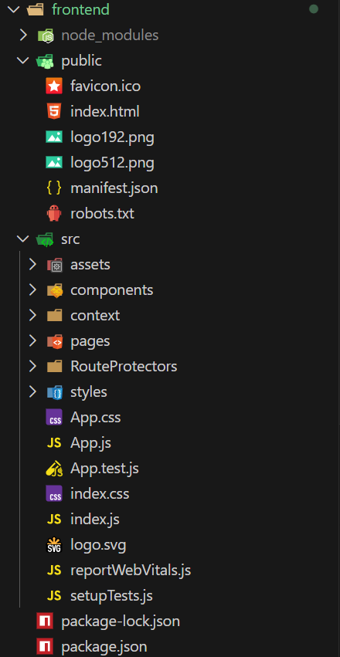

Backend:
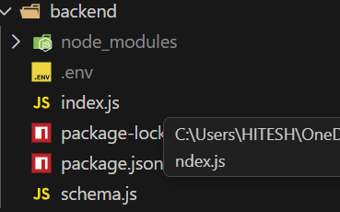

6. Running the Application
To start both servers:
Frontend:
Navigate to the client directory:
cd client
Start the development server:
npm start
The frontend application runs on: http://localhost:3000
Backend:
Navigate to the server directory:
cd server
Start the backend server:
npm start
The backend application runs on: http://localhost:5000
7. API Documentation
Base URL:
http://localhost:5000/api
Authentication Endpoints
• POST /auth/register – Register a new user (User/Admin)
• POST /auth/login – Login user and return JWT token
Flight Endpoints
• GET /flights – Get all available flights (with optional filters: source, destination, date)
• POST /flights (Admin – Protected) – Create a new flight
• PUT /flights/:id (Admin – Protected) – Update flight details
• DELETE /flights/:id (Admin – Protected) – Delete a flight
Booking Endpoints
• GET /bookings (Protected) – Get all bookings of logged-in user
• POST /bookings (Protected) – Create a new booking
• DELETE /bookings/:id (Protected) – Cancel a booking
User Endpoints
• GET /users/me (Protected) – Get logged-in user profile
• GET /users (Admin – Protected) – Get all registered users
8. Authentication
Authentication in FlightFinder is handled using JWT (JSON Web Tokens):
• Upon successful login, the system generates a JWT token.
• The token is sent to the client and stored in the browser's localStorage.
• All protected routes require a valid JWT token for access.
• The token must be included in the Authorization header as:
Bearer <token>
• Backend middleware verifies the token before granting access.
9. Screenshots or Demo
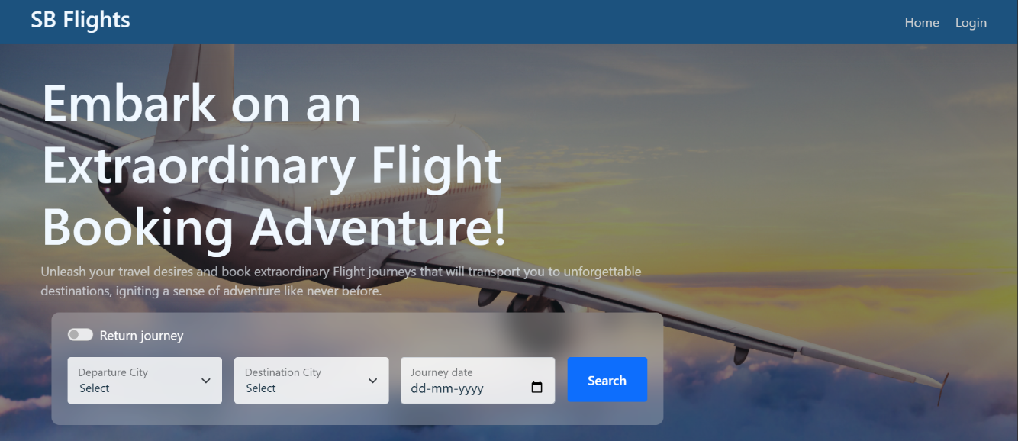
Home Page
Login Page:
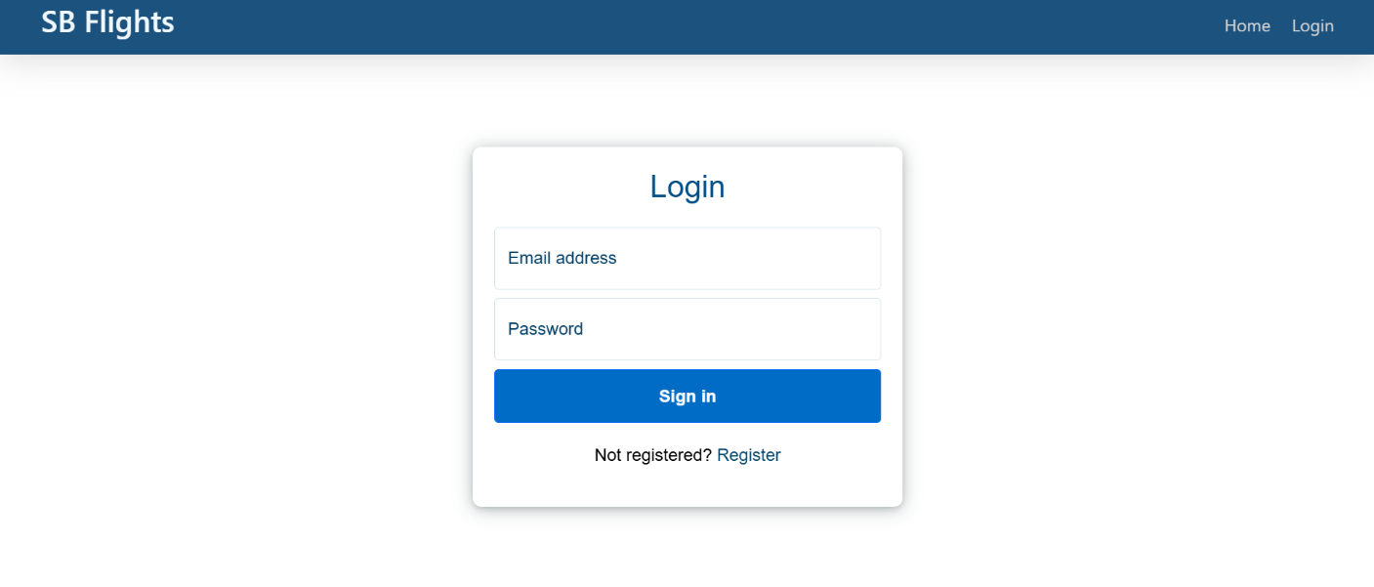

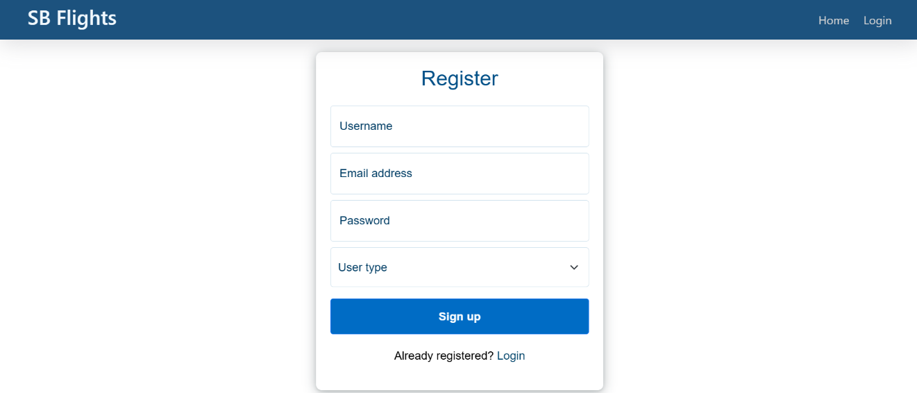
Register Page:

Admin Operations:
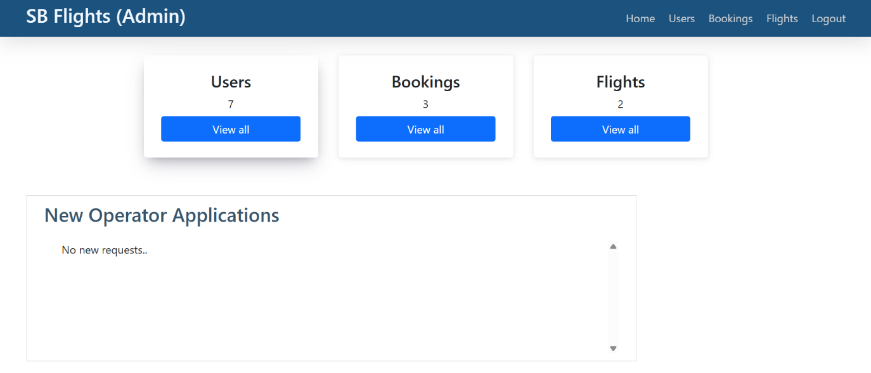

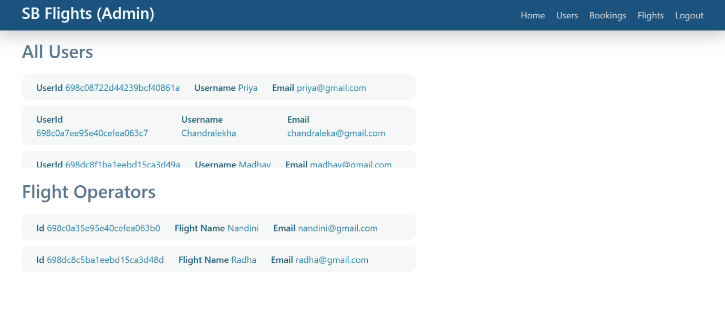

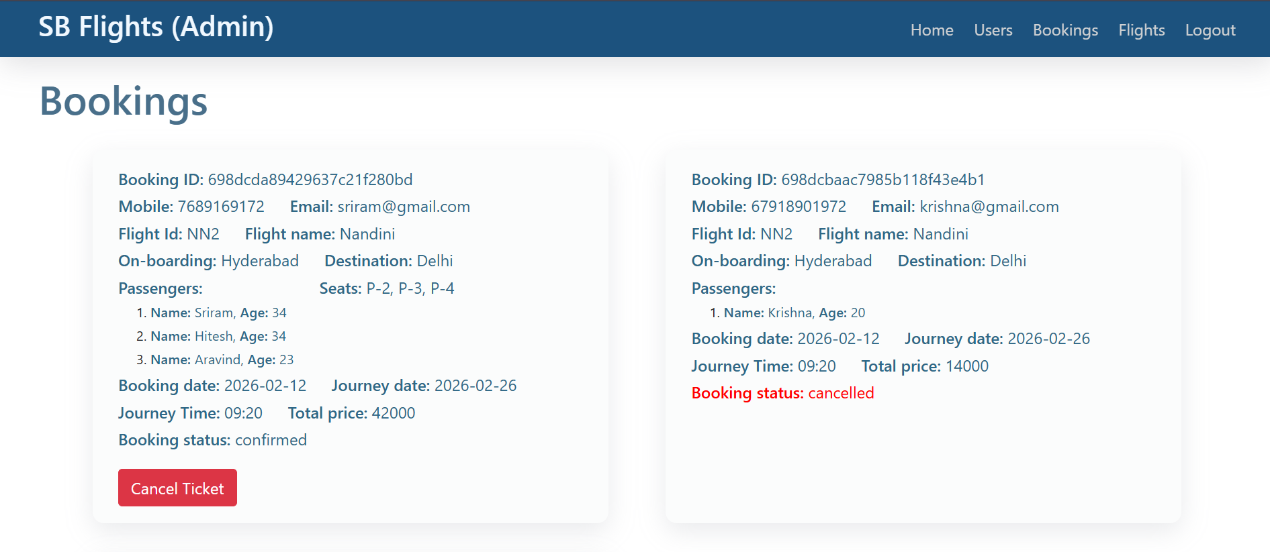

Flight Operator
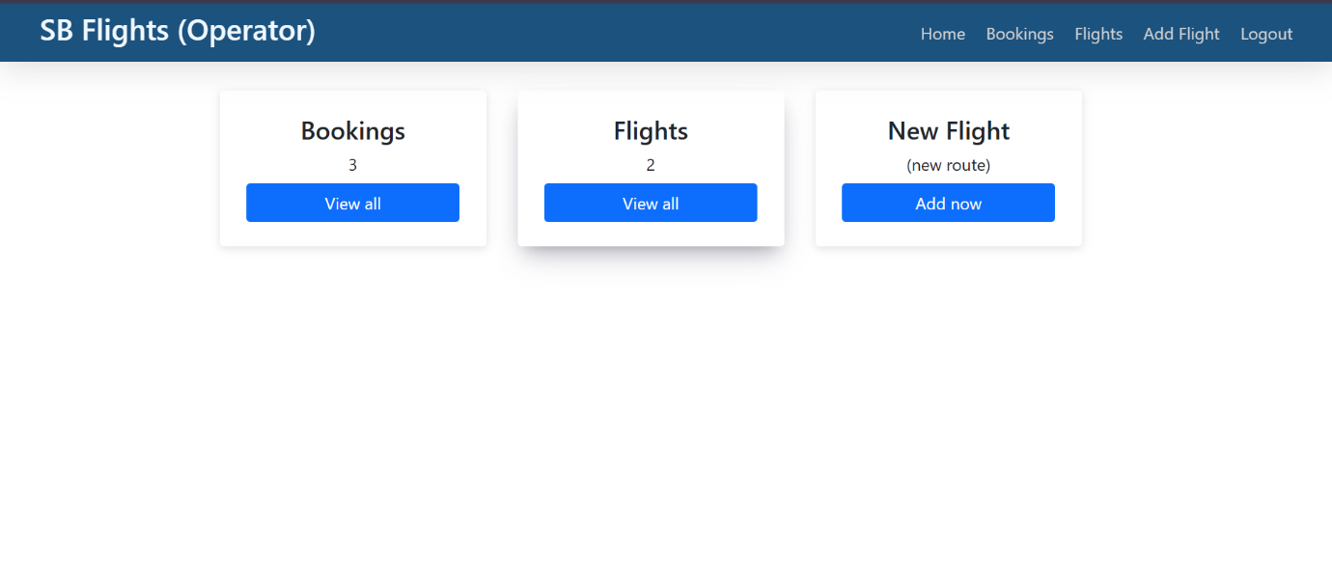
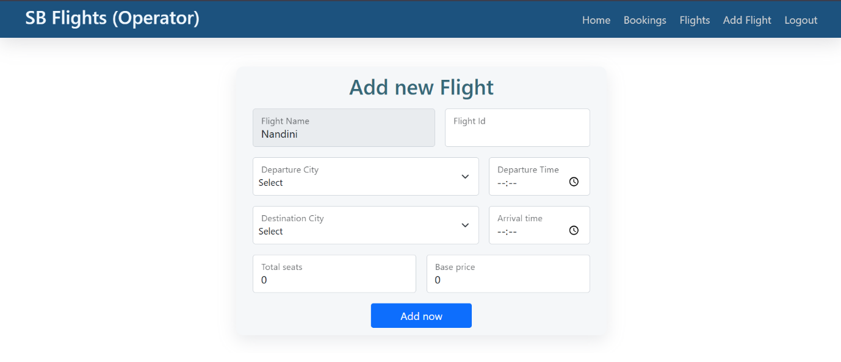

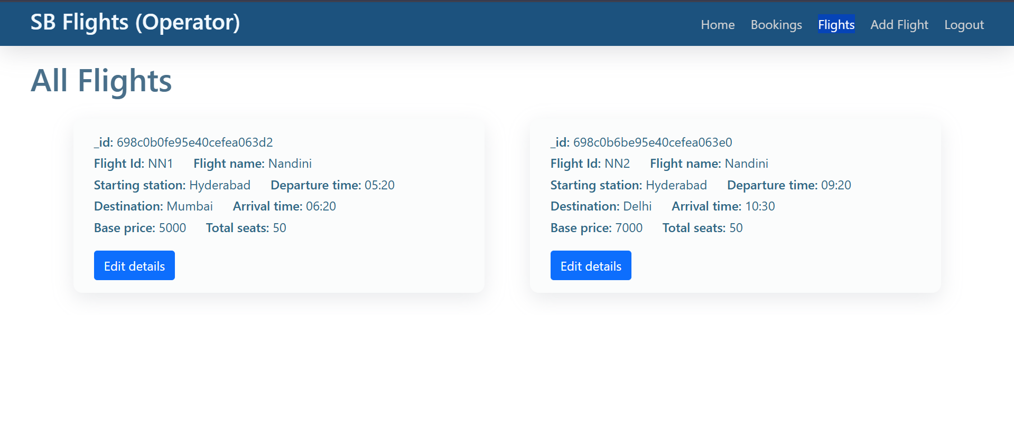

User operations:
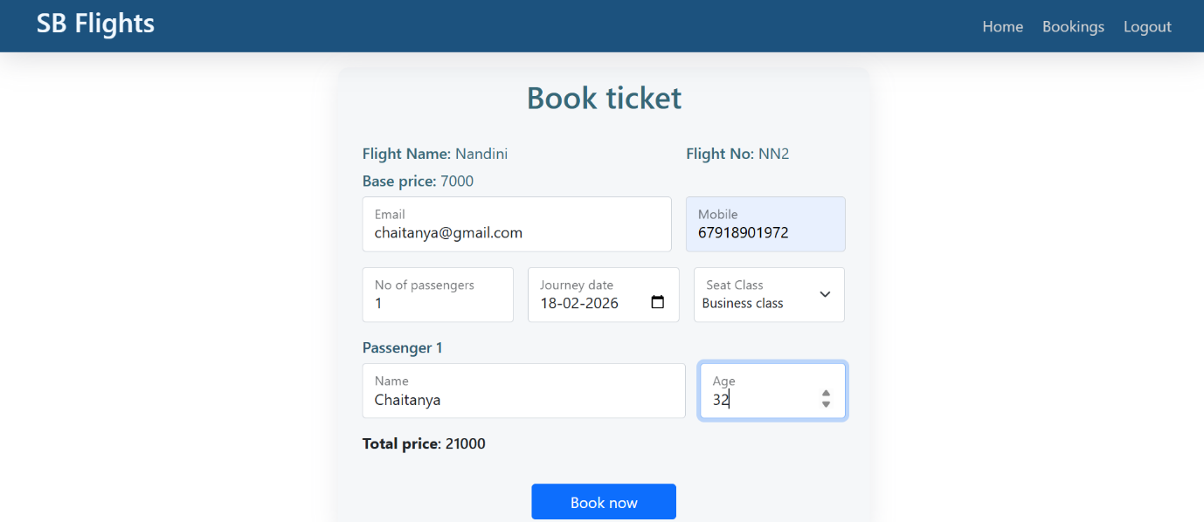

10. Testing
Testing Strategy:
• Frontend components are tested using Jest and React Testing Library to verify UI rendering, state updates, and user interactions.
• Backend APIs are tested using Mocha and Chai to validate responses, authentication, booking logic, and error handling.
• API endpoints are also tested using Postman for manual validation of requests and responses.
• End-to-end testing is performed using Cypress to simulate real user actions such as registration, login, flight search, and booking.
• Authentication and role-based access control are tested to ensure protected routes work correctly.
11. Known Issues
• Payment gateway integration is currently not implemented (future enhancement ready).
• Booking cancellation does not yet support refund processing logic.
• Admin dashboard responsiveness may be limited on smaller mobile screens.
• No email/SMS notification system implemented yet (manual confirmation only).
.
12. Future Enhancements
• Integrate secure online payment gateway (Razorpay / Stripe).
• Implement real-time seat updates using WebSockets.
• Add email and SMS notifications for booking confirmation and cancellation.
• Introduce price prediction or smart flight recommendations using AI/ML.
• Add hotel and travel package booking features.
• Develop a mobile application using React Native.
• Add multi-language and multi-currency support for global users.
• Implement refund and cancellation policy automation.

